











LAW SCHOOL RANKING
in association with

QUESTIONNAIRE 2026

Last Date to Submit: June 15, 2026

BW Businessworld Law School Ranking
QUESTIONNAIRE

GENERAL INFORMATION

- Name of the Institute:
- Address of the Institute:
- Phone number:
- Email ID:
- Website:
- Year of establishment:
- Name of the Director/ Head / Prinicipal
  - Email id:
  - Phone number:
- Please give Name and direct number of the person who should be contacted regarding information given for this survey.
  - Name:
  - Number:
  - Phone number:
- Affiliation of your college
  - Central University
  - State University
  - Deemed University
  - Private University
    - Name of the University
- Number of batches graduated since inception:
- With which of the following entrance tests is your Law School associated?
  - CLAT
  - LSAT
  - Any other:
- What was the cut off score/percentile of the entrance test for admission to your Law School?
- Is your Institute accredited by any other National/International / Regional Organization? If Yes, please provide the details:
- What is the fee a five year batch law student will be paying for a full time 5 year course?
- What is the fee a three year batch law student will be paying for a full time 3 year course?
- What is the percentage of female students in the outgoing batch?
- Does your institute have an alumni association
- If yes, is it registered/ registration details
- Number of alumni meetings held in the year 2025
- Any MOU’s signed with other colleges, bodies or firms during the year 2025

INFRASTRUCTURE

Campus area in acres |  | Acres
Total built up area (in sq. feet)
Number of books in library (related to law)
Number of electronic databases in library (give details)
Number of Faculty cabins
Number of Seminar Halls
Number of Auditoriums
Seating capacity of Auditorium
Number of amphitheater class rooms
 | Yes | No
Are residential facilities available in the campus for students?
Are residential facilities available in the campus for faculty members?
Is your campus Wi Fi?
Is every student of the flagship programme provided with a Laptop?
Number of single occupancy rooms for students
Number of double occupancy rooms for students

Number of Faculty houses

Please list the facilities that are available in your campus:

Facilities | YES | NO
Canteen
Cricket Ground
Basket Ball Court
Football Ground
Billiards Table
Swimming Pool
Lawn Tennis Court
Badminton Court
Squash Facilities
Gymnasium
Any other

Hostels: On Campus
No
Yes
No. of Students

No. of students
Hostels: Off Campus
No
Yes

- What is the capacity of the Library:
- Sitting capacity:
- Computer facility:
- Library timing:
- Number of books:
- Number of Journals:
  - National (Hardcopy)
  - International (Hardcopy)
  - Law related books added in 2025
- Does Law School publish any journal?
- If yes, title of the journal:
- LCD Projectors fitted in classroom:
- Please indicate teaching & learning aids used & made available to the students on regular basis:
- Is there a centralized portal for students and teachers to attend?
- Live online classes conducted Yes / No
- Pre-recorded lecture/tutorial session shared with students: Yes / No
- Was online classes recorded for future use Yes / No
- Was there any system in place to check the effectiveness online teaching? Yes / No
- How often is curriculum revised?
- By whom
[Institute/University/Regulatory authority]
- Are the corporate or other Law professionals consulted for curriculum designing? [Please mention the details]
- Please mention the Professional learning resources the Institute offers and what percentage of time is spent in such resources by the students:

Sl.  No. | Professional learning resources | Availabili ty [Yes / No] | Duration or Percentage of Time Spent
1 | Moot Court
2 | Internship
3 | Court Visits
4 | Professional training
5 | Interface With Legal Fraternity
6 | Case Study/Articles
7 | Any Other

- Total number of faculty in law school:
  - Male faculty:
  - Female faculty:
  - Faculty Student ratio:
  - Visiting Faculty:
- Please give the details of number of seminars and conferences (other than those organized by your institute) attended by your permanent faculty in the year 2025-26

- What was the total expenditure for faculty development in year 2025-26?

PLACAMENT

- Placement details for Law Programme:
  - Total number of students graduated:
  - Number of students placed (domestic)
  - Number of students placed (International)
  - Number of students opted for own practice:
  - Number of students opted for higher students:
  - Number of students not placed:
  - Total number of companies that visited the campus for placements:
  - Average salary offered (Domestic):
  - Average Salary offered (International):

AWARDS
- Number of Awards received by law students
  - International
  - National
  - State
  - Others
- Name of the events with details:
- Number of awards won by faculty
  - International
  - National
  - Other
- Number of research papers published by students in journals in 2025
  - Please share details, name of the student, year, name of the journal
- Number of research papers published by faculty in Journals in 2025

  - Please share details, name of the student, year, name of the journal
- Publications by law students online:
- Publication by faculty on online:
  - Please share details of the same
- Number of clubs run by law students:
- Name of the clubs
- Activities done by these club in the year 2025-26

- Please share notable achievements, initiatives of your law college that are significant to you or which makes the college stand out amongst others:

BW

#FutureOfLegalEducation #BWLawSchoolRanking

FUTURE OF LEGAL EDUCATION SUMMIT
LAW SCHOOL RANKING

LAW SCHOOL







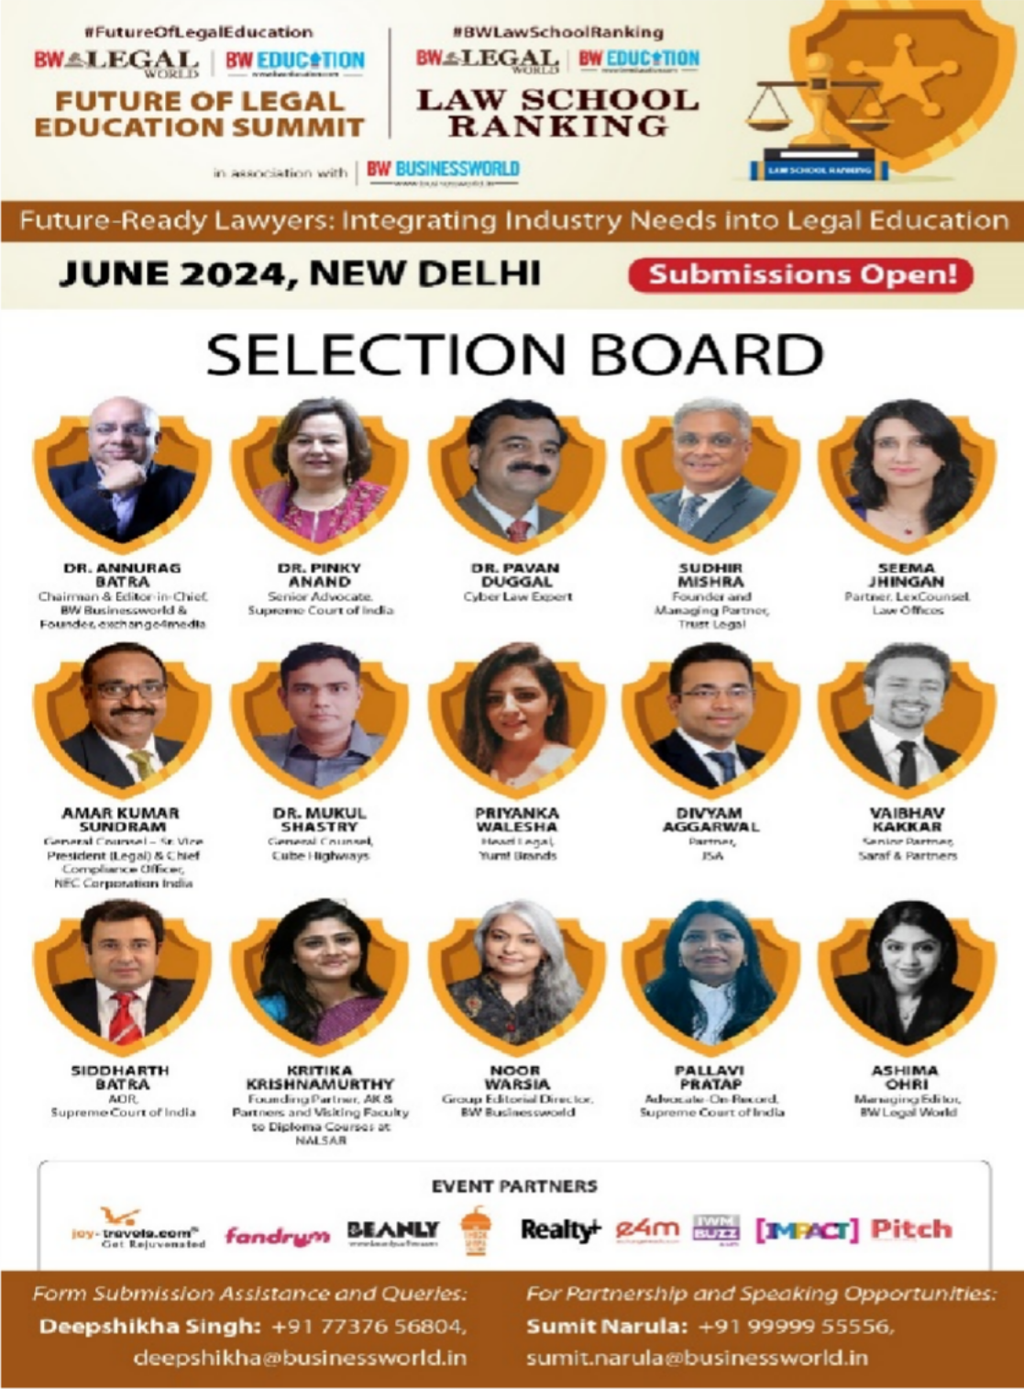
Future-Ready Lawyers: Integrating Industry Needs into Legal Education
JUNE 2024, NEW DELHI



















3 MILLION
PAGE VIEWS

THINK BUSINESS. THINK BW BUSINESSWORLD.

