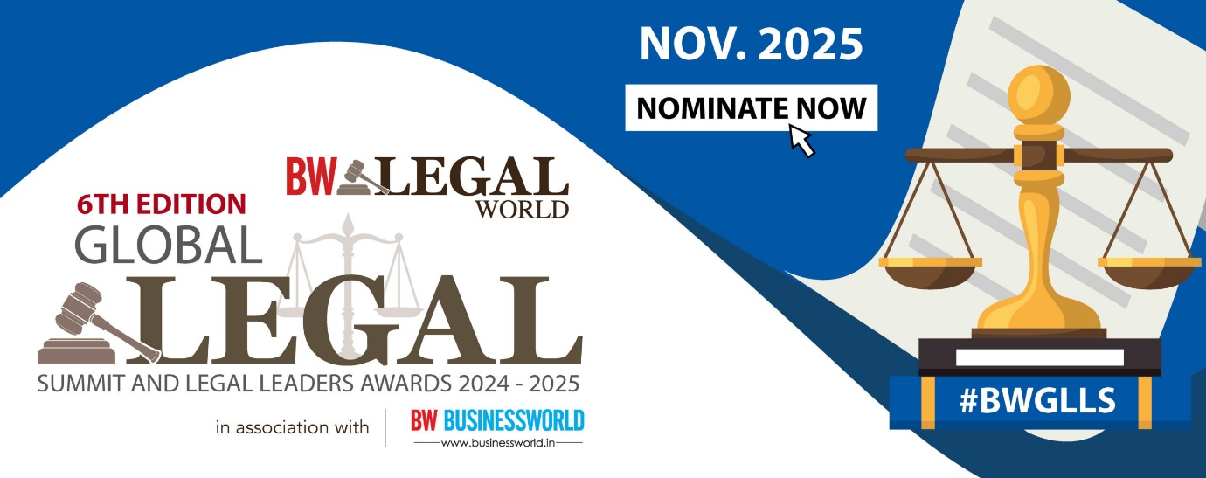

**Questionnaire for Organisational Categories**

|  |  |
| --- | --- |
| **Name of the Law Firm*:** |  |
| **Year of Establishment*:** |  |
| **Relevant Team Size *:** |  |
| **Name(s) of Partner in relevant practice area*:** |  |
| **Category of Award Nominated for*:** |  |
| **Locations Active\*** |  |

1. **Relevant Accomplishments in 2024 (please mention name of the partner heading each deal/matter. Please name clients wherever possible)* (Word Limit: 350 words)**
2. **Relevant accomplishments in 2023-2024 (please mention name of the partner heading each deal/matter. Please name clients wherever possible) * (Word Limit: 350 words)**
3. **Revenue generated by team in 2024 (Word Limit: 50 words)**
4. **Awards and Recognition** (List any awards or accolades received in the past 3 years)
5. **Any other details**

*As submitted by:*

**Name:**

**Designation:**

**Email:**

**Contact No:**

**Relevant Partner’s Email:**

**Relevant Partner’s Contact Number:**

**Relevant Partner’s LinkedIn URL:**

**Firms Twitter Handle:**

**Relevant Partner’s Signature:**