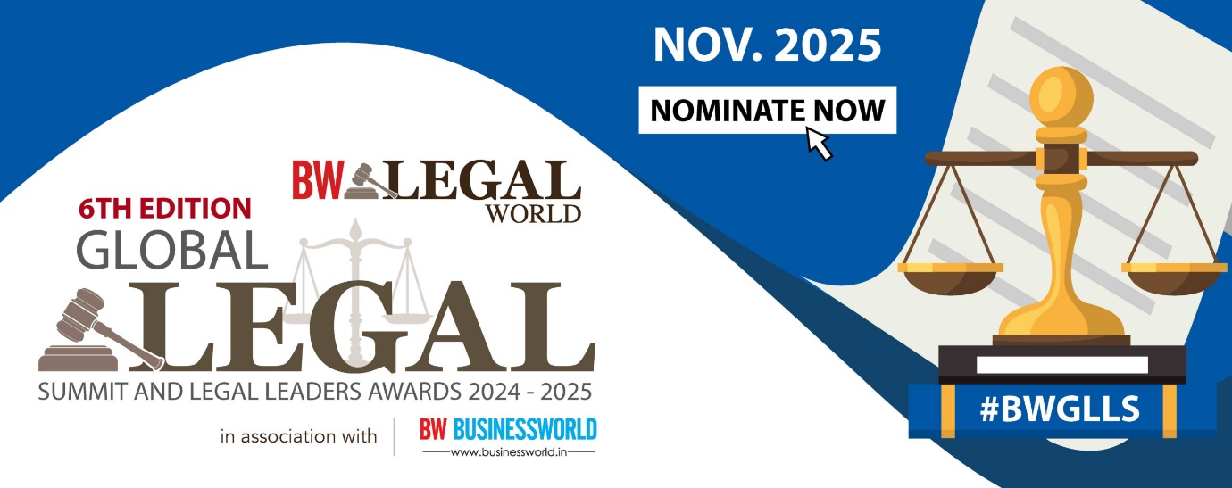

**Questionnaire for Individual Categories**

**Personal Information**

|  |  |
| --- | --- |
| **Name*:** |  |
| **Organisation*:** |  |
| **Designation*:** |  |
| **Year of Enrolment and Registration Number (if applicable) / Years of Practice\*** |  |
| **Category of Award Nominated for\*** |  |
| **Relevant Practice Areas\*** |  |
| **Locations Active\*** |  |

**Professional Details**

1. **Key Achievements in the Past Year Related to the Selected Sub-Category (e.g., landmark cases, successful transactions, innovative solutions, etc.) \***
2. **Associations/Memberships* *(Word Limit: 100 words)***
3. **Awards or Recognition Received in the Past\***
4. **Brief Bio* *(Word Limit: 150 words)***
5. **Describe the Nominee’s Impact on the Legal Community or Industry*:  
   *(Max 250 words)***
6. **Any other details *(Word Limit: 50 words) \****

**Declaration by the Nominee:  
*I hereby declare that the information provided above is true and accurate to the best of my knowledge.***

* **Agree**