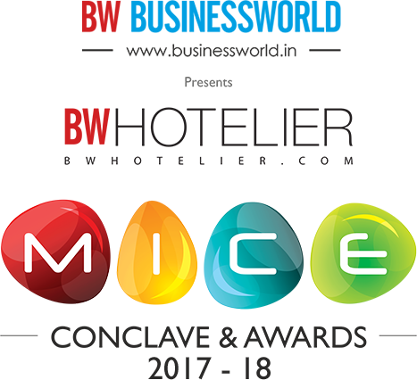

AWARD CATEGORY (PLEASE TICK ONE)

Best Travel Company Promoting MICE -- Inbound
Best Travel Company Promoting MICE -- Outbound

Best Event Manager -- Inbound
Best Event Manager -- Outbound

Best Wedding Destination -- Inbound
Best Wedding Destination -- Outbound

Best Convention Destination -- Inbound
Best Convention Destination -- Outbound

Best MICE Hotel -- Indian
Best MICE Hotel -- International

Best Tourism Office -- Indian
Best Tourism Office -- International

Best Marketing Campaign -- Digital
Best Marketing Campaign -- Print
Best Marketing Campaign -- Television

NAME OF ORGANIZATION:

SHORT ORGANIZATION BACKGROUND (not more than 300 words):

(Assessment Criteria for Best Travel Company Promoting MICE):
Turnover from MICE; No. of People Moved in India / Overseas; Important MICE Movements Handled

(Assessment Criteria for Best Event Manager/ Best Marketing Campaign:
Work Sample

(Assessment Criteria for Best Wedding Destination/ Best Convention Destination/ Best Tourism Office):
No. of Weddings / Conventions from India / Promotion of New Destinations / Experiences

(Assessment Criteria for Best MICE Hotel):
No. of MICE Guests & Events; Percentage of Business from MICE

Please Note: All figures should be for 2016-2017.

PLEASE FILL THE DOWNLOADED FORM AND EMAIL IT TO sakshi@businessworld.in, nitesh@businessworld.in
For Any Queries, Please Contact – Sakshi; sakshi@businessworld.in; 9555963235
Nitesh Kumar; nitesh@businessworld.in; +91 9999348613

